GLOBAL RECIPROCAL COLLEGES
COLLEGE OF COMPUTER STUDIES
SYSARC 1
SYSTEM INTEGRATION AND ARCHITECTURE 1
SCHOOL CLINIC PATIENT AND MEDICINE INVENTORY MANAGEMENT SYSTEM
A FEASIBILITY STUDY
PRESENTED TO THE COLLEGE OF COMPUTER STUDIES OF GLOBAL RECIPROCAL COLLEGES
IN PARTIAL FULFILLMENT OF THE REQUIREMENTS FOR THE DEGREE OF BACHELOR OF SCIENCE IN INFORMATION TECHNOLOGY
ATON, KIMPEE M.
CASTILLANO, GERALDYN R.
CORTEZ, HANNY I.
ISIP, JERICK RUPERT D.
PANTUA, RYAN C.
SALIBIO, CRISTIAN PAUL L.
REINERIO Z. QUINTO, JR.
ADVISER

2ND SEMESTER ACADEMIC YEAR 2024-2025

Table of Contents
- Acknowledgements 4
- Dedication 4
- Scopes and Objectives 5
  - Project Name and Description 5
  - Project Scopes 5
  - Project Deliverables 6
  - Project Objectives 7
  - Project Constraints 8
- Company Profile 9
  - Functional Decomposition Diagram (FDD) 9
- Existing System 9
  - Existing System Flowchart 10
- Statement of the Problem 11
  - Solution 12
- Proposed System 13
  - Characteristics 13
  - Processes 14
  - Functional Decomposition Diagram 15
  - System Flowchart 16
  - Data Flow Diagram 17
  - Detailed Data Flow Diagram 17
- Cost and Benefit Analysis 18
  - DEVELOPMENT COST 18
  - HARDWARE COST 18
  - OTHER MISCELLANEOUS COST 18
  - TOTAL ESTIMATED DEVELOPMENT COST 19
- Appendix 20
- Group Picture 21
- Resume 22

Acknowledgements
The proponents would like to express their sincere appreciation to their System Integration and Architecture (SYSARC) instructor for the guidance, patience, and opportunity given to complete this project. The chance to further develop this system has allowed the proponents to apply and strengthen their knowledge in system integration and architectural design.
The proponents also extend their gratitude to the school clinic personnel and administration for the information that helped in understanding clinic operations and requirements.
Lastly, heartfelt thanks are given to the proponents’ families and friends for their continued encouragement and support throughout the completion of this project.

Dedication
This project is dedicated to our families, mentors, and educators whose patience, guidance, and belief motivated us to persevere and complete this academic requirement

Scopes and Objectives

Project Name and Description
Project Name: School Clinic Patient and Medicine Inventory Management System
Project Description
The School Clinic Patient and Medicine Inventory Management System is an integrated system designed to record, monitor, and manage student clinic consultations and first-aid medicine inventory. It allows clinic staff, nurses, and clinic assistants to log patient visits, track symptoms and treatments, and monitor medicine availability, usage, and expiration dates. The system aims to improve efficiency, reduce manual record-keeping, and ensure accurate, real-time tracking of patient care and medicine resources within the school clinic.

Project Scopes
The School Clinic Patient and Medicine Inventory Management System focuses on managing student clinic consultations and first-aid medicine inventory within the school clinic. The system is designed for use by authorized clinic personnel to ensure accurate record-keeping and efficient clinic operations.

Project Deliverables
- Patient Monitoring
  - Recording patient clinic visits
  - Logging symptoms, reasons for consultation, and treatments provided
  - Storing basic patient information for clinic reference
- Medicine Inventory Management
  - Recording available first-aid medicines
  - Monitoring stock quantities and expiration dates
  - Tracking medicine usage based on patient treatments
- Integrated System Functions
  - Automatic deduction of medicine stock after treatment is recorded
  - Real-time update of medicine availability
- Search and Retrieval
  - Searching student patient records
  - Searching medicine details quickly and accurately
- Data Management
  - Secure storage of patient and medicine records
  - Backup and basic data recovery features

Project Objectives
To address the identified problems in the school clinic, we propose the development of a School Clinic Patient and Medicine Inventory Management System.

The proposed system will computerize the recording and monitoring of student clinic consultations by allowing clinic staff, nurses, and clinic assistants to log patient visits, symptoms, reasons for consultation, and treatments provided in a centralized database. This will ensure organized, accurate, and easily retrievable patient records.

The integration of patient monitoring and medicine inventory will eliminate inconsistencies between treatment records and medicine usage. A built-in search function will enable users to quickly locate patient records or specific medicines, reducing delays in clinic operations.

Project Constraints
The development and implementation of the School Clinic Patient and Medicine Inventory Management System are subject to the following constraints.
- Time Constraint - The system must be designed, developed, tested, and completed within the limited timeframe of the academic semester.
- Budget Constraint - The project has a limited budget and relies primarily on free and open-source software and existing school hardware.
- Technical Constraint - The system is limited to basic patient monitoring and medicine inventory functions and does not include advanced medical diagnosis or automated prescription features.
- Hardware Constraint - The system depends on the availability and performance of existing clinic computers and equipment.
- User Training Constraint - Clinic staff and assistants may have limited technical knowledge, so the system must remain simple and easy to use.
- Data Accuracy Constraint - The accuracy of system records depends on the correct and timely data entry by clinic staff and assistants.
- System Scope Constraint - The system is intended for use within the school clinic only and will not be accessible outside the school environment.

Company Profile
Department: GRC Clinic Department
Company Address: GRC Building, 454, 1400 Rizal Ave Ext, Grace Park East, Caloocan, Metro Manila
Type of Department: Health Services Unit
Overview of the Department
The School Clinic is a healthcare unit within the educational institution that provides basic medical services to students. It is responsible for handling student consultations, first-aid treatments, and monitoring the health conditions of students during school hours.
The clinic plays an important role in ensuring student safety and well-being by providing immediate medical attention and maintaining essential first-aid medicines.

Functional Decomposition Diagram (FDD)
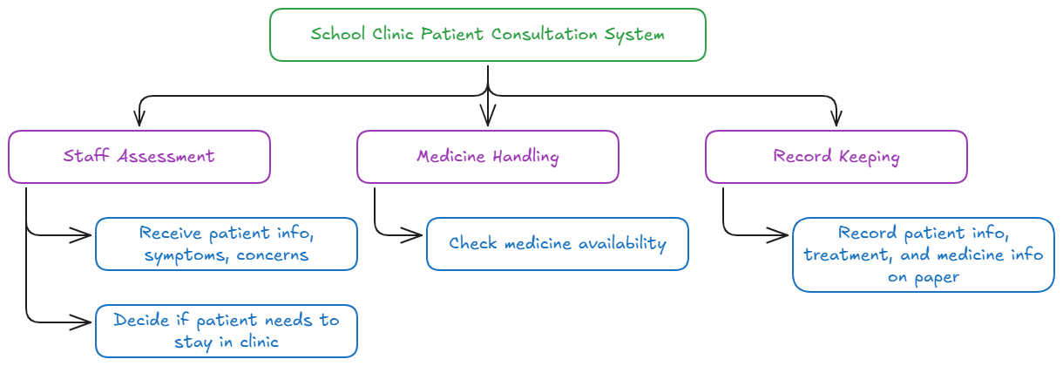

Existing System
At present, the School Clinic primarily relies on manual and paper-based methods for recording student visits and managing medicine inventory. This approach may lead to difficulties in record retrieval, inaccurate medicine tracking, and delays in service delivery.

Existing System Flowchart
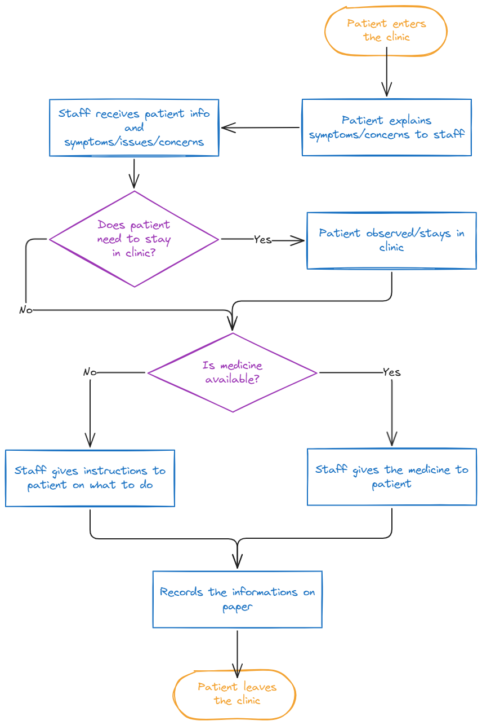

Statement of the Problem
The School Clinic plays an essential role in providing basic healthcare services to students. However, the clinic currently relies on manual and paper-based methods for recording student consultations and managing first-aid medicine inventory. This traditional approach leads to several operational challenges.

Patient records are difficult to organize, retrieve, and monitor, especially when tracking previous clinic visits, symptoms, and treatments provided. Manual record-keeping increases the risk of incomplete, inaccurate, or misplaced patient information, which can delay medical assistance and affect the quality of care given to students.
The lack of integration between patient treatment records and medicine inventory further complicates clinic operations. Medicine usage is not automatically recorded, leading to inconsistencies between actual stock levels and recorded inventory data.

Therefore, there is a need for an integrated system that can efficiently record and monitor student patient consultations while simultaneously managing first-aid medicine inventory. Such a system will improve data accuracy, enhance clinic efficiency, and support better healthcare service delivery within the school.

Solution
To address the identified problems in the school clinic, we propose the development of a School Clinic Patient and Medicine Inventory Management System.

The proposed system will computerize the recording and monitoring of student clinic consultations by allowing clinic staff, nurses, and clinic assistants to log patient visits, symptoms, reasons for consultation, and treatments provided in a centralized database. This will ensure organized, accurate, and easily retrievable patient records.

The integration of patient monitoring and medicine inventory will eliminate inconsistencies between treatment records and medicine usage. A built-in search function will enable users to quickly locate patient records or specific medicines, reducing delays in clinic operations.

Overall, the proposed system will reduce manual paperwork, minimize data entry errors, improve clinic efficiency, and support safer and more effective healthcare services for students.

Proposed System
The proposed School Clinic Patient and Medicine Inventory Management System aims to improve clinic operations by digitizing patient records and integrating medicine inventory management. The system will help clinic staff, nurses, and clinic assistants efficiently record student consultations, monitor medicine availability, and ensure accurate usage tracking.

Characteristics
The proposed system is a web-based School Clinic Patient and Medicine Inventory Management System designed to improve the efficiency and organization of clinic operations. Due to the continuous advancement of technology, the system aims to replace the existing manual and paper-based methods used in recording student clinic consultations and managing first-aid medicine inventory.

Unlike systems that require individual user accounts, the proposed system does not include a user login feature. The system is intended to be accessed directly through designated clinic computers and used only by authorized clinic staff, nurses, and clinic assistants. This approach simplifies system usage and ensures faster access during emergency or high-volume clinic situations.

The system utilizes a centralized database to store patient records and medicine inventory data. It automatically updates medicine stock levels based on recorded treatments, reduces paperwork, improves data accuracy, and allows quick retrieval of patient and medicine information.

Processes
Step 1: System Access
- Clinic staff, nurses, or clinic assistants access the system directly from the clinic computer
- No login or credential verification is required
Step 2: Patient Registration and Consultation Recording
- Register new student patient information
- Search and select existing patient records
- Record symptoms, reason for consultation, and date of visit
Step 3: Treatment and Medicine Recording
- Record treatments or first-aid services provided
- Select medicines used during the consultation
- The system automatically deducts medicine quantities from the inventory
Step 4: Medicine Inventory Management
- Add new medicine stocks to the system
- Monitor available medicine quantities and expiration dates
- View real-time updates of medicine inventory
Step 5: Search and Record Retrieval
- Search and retrieve patient consultation records
- Search medicine details quickly and accurately
Step 6: Data Storage and Maintenance
- All patient and medicine records are stored in a centralized database
- Data backup can be performed to prevent record loss

Functional Decomposition Diagram
/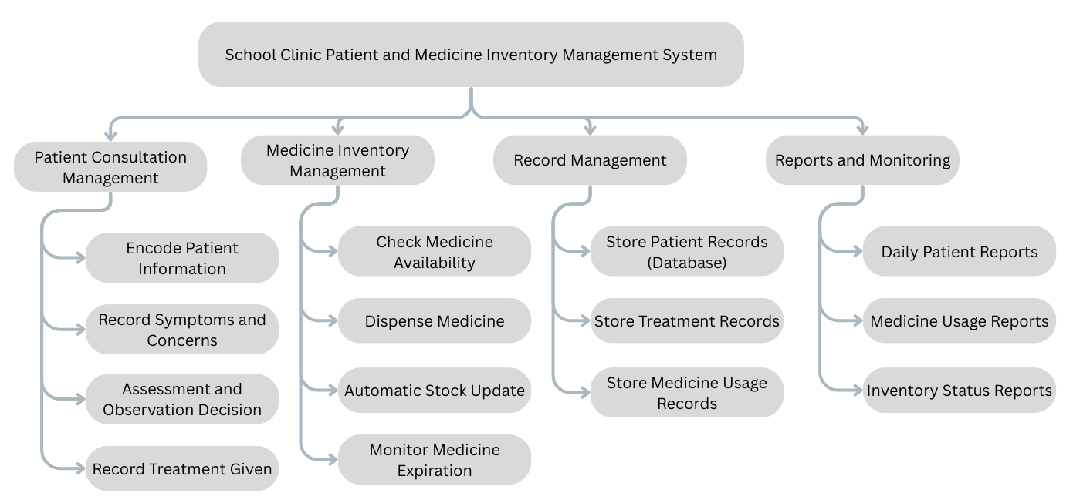

System Flowchart

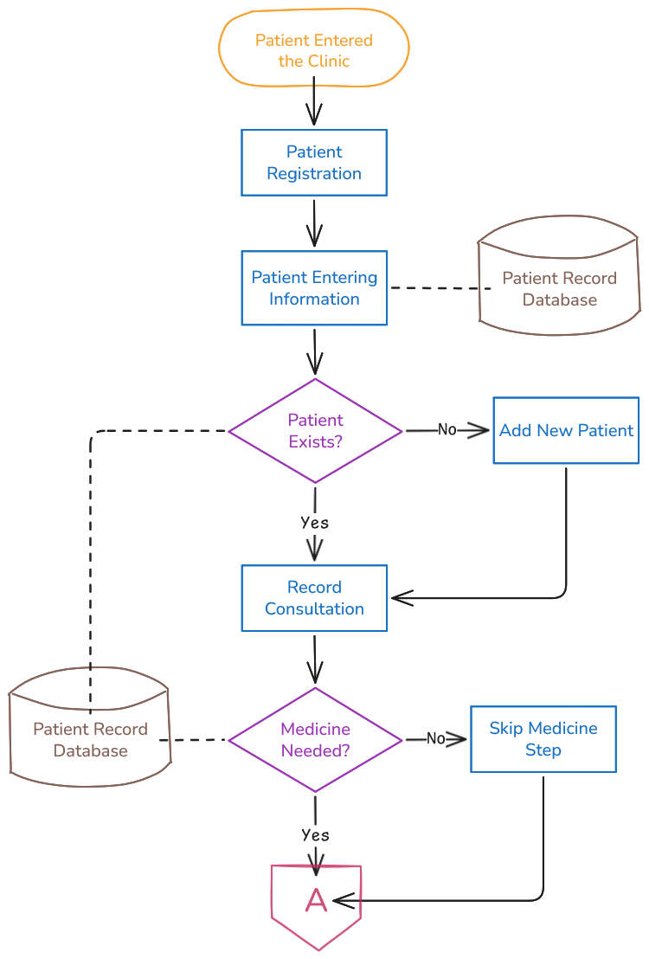

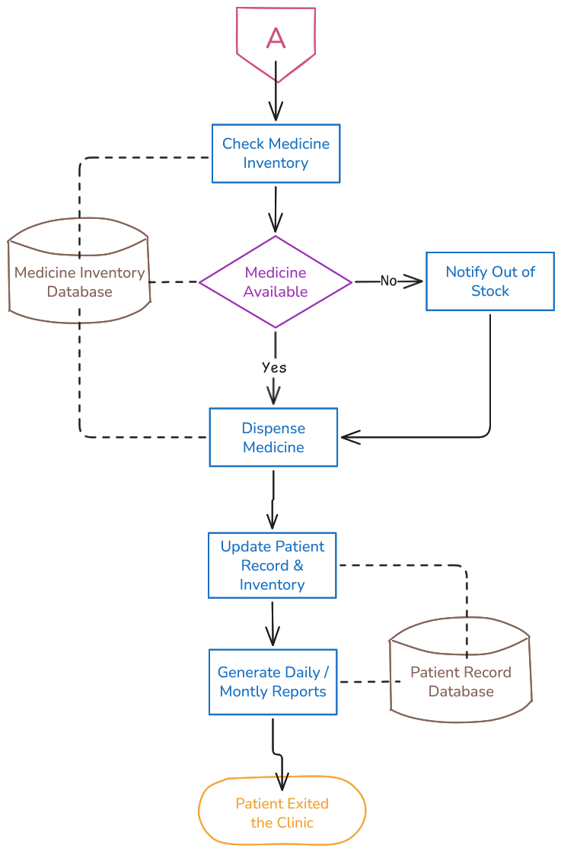

Data Flow Diagram
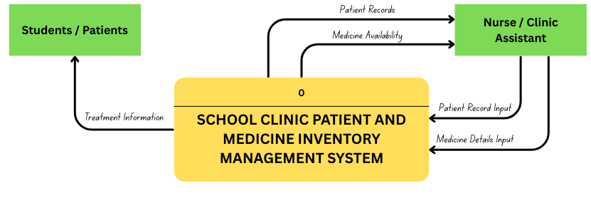

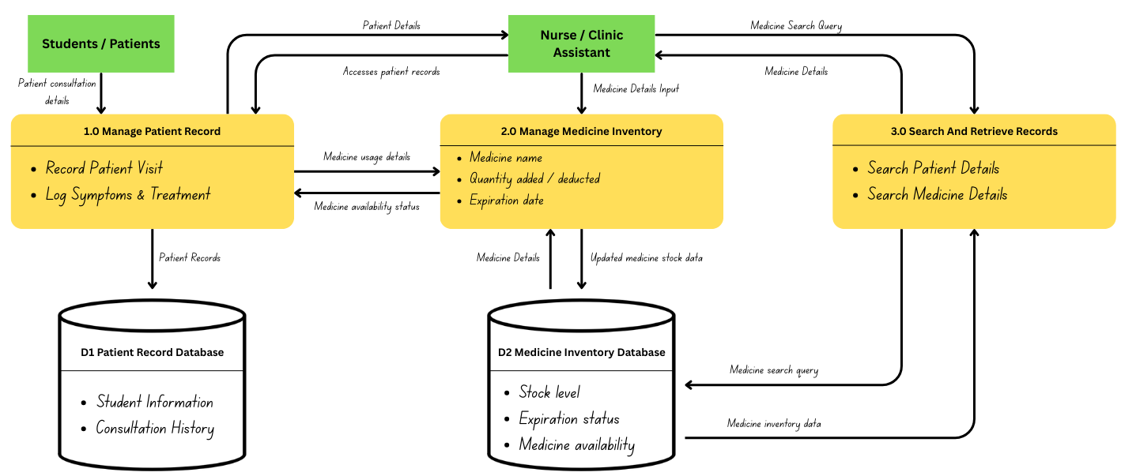
Detailed Data Flow Diagram

Cost and Benefit Analysis
The Cost and Benefits Analysis evaluates the financial, operational, and qualitative impacts of implementing the proposed School Clinic Patient and Medicine Inventory Management System. The analysis focuses on identifying the resources required for system development and operation, as well as the advantages gained in terms of efficiency, accuracy, and quality of clinic services. Overall, the implementation cost of the system is relatively minimal compared to the significant operational and service-related benefits it provides.

DEVELOPMENT COST
Expense Category | Estimated Cost (PESO) | Description
System Development | ₱0 | Design, coding, and testing of the web-based system (student-developed)
Database Setup | ₱0 | Use of free/open-source database - PostgreSQL
Web Framework & Tools | ₱0 | Open-source technologies (HTML, CSS, TypeScript)

HARDWARE COST
Expense Category | Estimated Cost (PESO) | Description
Computer | ₱0 | Existing clinic computer
Peripheral Devices | ₱0 | Keyboard, Mouse, Monitor (already available)

OTHER MISCELLANEOUS COST
Expense Category | Estimated Cost (PESO) | Description
Electricity and Utilities | ₱1,500 | Power consumption for operating the computer during clinic hours
Internet and Utilities | ₱1,500 | Internet connection used for system access, updates, and backups

TOTAL ESTIMATED DEVELOPMENT COST
Cost Category | Estimated Cost (PESO)
Development Cost | ₱0
Hardware Cost | ₱0
Other Miscellaneous Cost | ₱3,000
TOTAL ESTIMATED DEVELOPMENT COST | ₱3,000

Appendix
Definition of Terms
- Patient Record - refers to the digital file containing a student’s clinic visit details, including symptoms, treatments, and consultation history.
- Medicine Inventory - refers to the list of available first-aid medicines in the clinic, including stock quantities and expiration dates.
- Consultation Log - refers to the recorded details of a student’s visit to the clinic, including the reason for consultation and treatment provided.
- Treatment Record - refers to the documented medical assistance or first-aid given to a student during a clinic visit.
- Stock Deduction - refers to the automatic reduction of medicine quantity in the inventory once a treatment record is saved.
- System User - refers to authorized clinic personnel such as nurses, clinic assistants, or administrative staff who operate the system.
- Database - refers to the structured collection of patient and medicine records stored electronically for easy retrieval and management.
- Search Function - refers to the built-in feature that allows users to quickly locate patient records or medicine details.
- Data Backup - refers to the process of creating a copy of patient and medicine records to prevent data loss in case of system failure.
- System Constraint - refers to the limitations affecting the system, such as time, budget, hardware, and user training.
- System Analyst - refers to the individual responsible for analyzing clinic processes, designing the system, and ensuring that requirements are met.

Data Dictionary
Name | Description | Attribute Name | Attribute Type | Size | Sample | Location
Patient ID | Unique primary key for the student | patient_id | SERIAL | 4 bytes | 101 | patients_db.sql
Student Number | Unique school ID number of the student | student_no | VARCHAR | 20 | 2024-0012 | patients_db.sql
First Name | Student's given name | first_name | VARCHAR | 50 | Juan | patients_db.sql
Last Name | Student's family name | last_name | VARCHAR | 50 | Dela Cruz | patients_db.sql
Course/Grade | Grade level or academic course | level_section | VARCHAR | 30 | Grade 10-A | patients_db.sql
Medicine ID | Unique primary key for medicine item | medicine_id | SERIAL | 4 bytes | 501 | inventory_db.sql
Medicine Name | Name of the first-aid medicine | med_name | VARCHAR | 100 | Paracetamol | inventory_db.sql
Description | Brief detail of medicine use | med_desc | TEXT | N/A | For fever and pain | inventory_db.sql
Stock Quantity | Current number of units available | stock_qty | INTEGER | 4 bytes | 150 | inventory_db.sql
Expiration Date | Date when medicine becomes invalid | expiry_date | DATE | 8 bytes | 2027-12-31 | inventory_db.sql
Consultation ID | Unique ID for each clinic visit | consult_id | SERIAL | 4 bytes | 9001 | consultations_db.sql
Visit Date | Date and time of consultation | visit_timestamp | TIMESTAMP | 8 bytes | 2026-01-27 14:30 | consultations_db.sql
Symptoms | Symptoms reported by the patient | symptoms | TEXT | N/A | Headache and dizziness | consultations_db.sql
Treatment | Treatment or first-aid provided | treatment | TEXT | N/A | Provided 1 tablet & rest | consultations_db.sql
Quantity Issued | Number of medicine units given | qty_issued | INTEGER | 4 bytes | 1 | consultations_db.sql

Group Picture


Resume

2 X 2 ID picture with white background

Ryan Pantua
C. Perez St. Tonsuya, Malabon City
09098868332
Cambelryan5@gmail.com

PROFESSIONAL OBJECTIVE:
Seeking for a part time job for, so I can pay my expenses. Therefore, at the same time gaining experience and hone my communication skills.

EDUCATION:
College Global Reciprocal Colleges - Currently
Bachelor of Science in Information Technology

Senior High School Arellano University Jose Rizal Campus - 2021-2023
Information and Communication Technology
Gov. Pascual Avenue, Malabon City

Junior High School Southville 8B National High School – 2017-2020
San Isidro Rodriguez Montalban Rizal

Elementary Southville 8 Elementary School– 2011-2017
San Isidro Rodriguez Montalban Rizal

WORKING EXPERIENCE:
None

SKILLS:
- Communication
- motivated
- Problem-solving

SEMINARS / WORKSHOPS ATTENDED:
GK College of Business, Arts, and Technology - i did a Work Immersion seminar there when i was a Senior High School student.

I hereby certify that all the information above is true and correct based on my best knowledge and honesty.


Aton, Kimpee
Student
Enthusiastic and dedicated Information Technology student with a passion for technology and innovation. Eager to gain hands-on experience and apply classroom knowledge to real-world challenges. Known for being a fast learner, team player, and adaptable individual with strong problem-solving and analytical skills.

CONTACT
k1mpeeaton06@gmail.com
https://kimpeea.github.io/FinalProject/
EDUCATION
Global Reciprocal Colleges
Bachelor of Information Technology
2nd Year
( 2023-2025 )

Bagong Barrio Senior High School
( 2022-2023 )

Electron College of Technical Education
( 2020-2021 )

Bagong Barrio National
High School
( 2016-2020 )

SKILLS
Collaborative Leadership Creative
Direction
Adaptability & Open-mindedness
Analytical Observation
WORK EXPERIENCE

N/A


Isip, Jerick Rupert D.
Self-Taught Developer

Self-taught and passionate about creating interactive digital experiences through games and software. Looking to contribute to real-world projects while continuing to grow in design, problem-solving, and development.

Skills and Technologies
Comfortable with:
- C/C++, Python, C3
- Linux (ArchLinux), Windows
- Git, Neovim/Vim.
Familiar with:
- HTML, CSS, Javascript
- C3, Java, Lua
- VSCode, Visual Studio

Education

Global Reciprocal Colleges
Bachelor of Information Technology
( 2023 - Present )

Electron College of Technical Education
Information and Computer Technology

Maria Clara High School

Cayetano Arellano Elementary School
79 Mabalacat St 6th Ave
Caloocan City

Contact
09957692367

Primary Email
nexushastaken@gmail.com
Secondary Email
jerickrupertisip@gmail.com

Socials
Facebook Link
https://web.facebook.com/isip.jerick.rupert

Github Profile
https://github.com/NexushasTaken

Discord
nexus.null


SALIBIO, CRISTIAN PAUL L.

170.

Gen Evangelista St. Bagong Barrio Caloocan City

09271850702

cristiansalibio7@gmail.comail.com

OBJECTIVE

As a student, I pride myself on being a responsible and organized individual. I am enthusiastic about embarking on my first professional experience and eager to contribute to a workplace environment that values dedication and precision.

EDUCATIONAL BACKGROUND
College Bachelor of Science in Information Technology (BSIT)
Global Reciprocal Colleges GRC, 2024 – Present
GRC Building, Rizal Ave Ext, Grace Park East, Caloocan City

Senior High School Information and Communication Technology (ICT)
Electron College of Technical Education, 2019 – 2021
10th ave, Grace Park East, Caloocan City

Junior High School Bagong Barrio National High School, 2016 – 2020
De Castro Street, Bagong Barrio, Caloocan City

Elementary Bagong Barrio Elementary School, 2010 – 2016
Malolos Ave. Bagong Barrio Caloocan City

PERSONAL DATA:
Skill
- Empathic listener
- Self-possesion
- Diligent
- Flexible

D 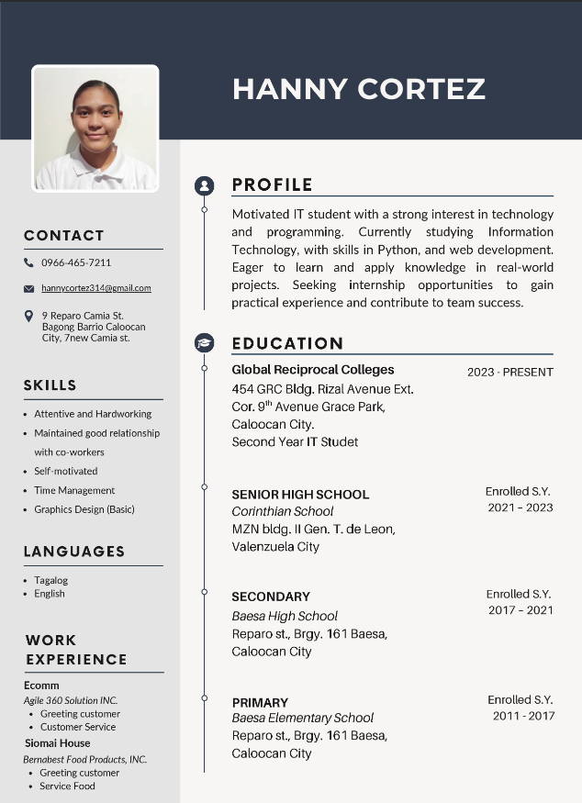

 |  | PERSONAL INFORMATION

Gender : Female
Age : 21
Date of Birth : November 12, 2003
Place of Birth : Fabella Memorial Hospital
Religion : Born again Christian
Nationality : Filipino

Geraldyn R. castillano  OBJECTIVES  To secure a position that leverages my technical skills, educational background, and collaborative abilities, with a focus on applying my knowledge in IT industry and grow professionally.  CONTACT  PHONE: 09513710068  Email Address: castillanogeraldyn@gmail.com  Address: Blk 38 lot 6 ph-3 F1 J Dagat- dagatan  Lapu-lapu Ext. Barangay 12 Caloocan City |  | EDUCATION

NAME OF SCHOOL SCHOOL TERM

ELEMENTARY : NINOY AQUINO ELEMENTARY SCHOOL 2010 – 2016 MAYA MAYA ST. MALABON CITY

JUNIOR HIGH SCHOOL : M.B.ASISTIO SR.HIGH SCHOOL 2016 – 2020 PAMPANO ST., KAUNLARAN VILLAGE, CALOOCAN CITY

SENIOR HIGH SCHOOL : IMELDA INTEGRATED SECONDARY SCHOOL 2021 – 2023 HASA-HASA ST. COR. LANGARAY ST., LONGOS, MALABON CITY

COLLEGE : GLOBAL RECIPROCAL COLLEGES 2023 - Present
GRACE PARK, CALOOCAN CITY
 |  | PERSONAL SKILLS
  - Passionate
  - Responsible
  - Self-Motivated
  - Take up new challenges
  - Good in Team work
  - Hospitable
  - Humble and Friendly

